
MSE320 - Machine Design
11/04/2024

Midterm Report

for Gravel Conveyor

Project Group: #12

YUVRAJ GHUMAN - 301397105
KEENAN D'SENA - 301460424
KEITARO BONAFE - 301472060
AMRAZ MANGAT - 301368895
THANH NAM TRAN - 301540228

Table of Contents

Table of Contents 2
I. Introduction 3
II. Project Progress and Completed Activities 3
1. Conceptual Design (October 1 - October 15) 3
2. Preliminary Design (October 16 - November 15) 3
III. Analysis and Findings 8
Assumptions 8
Initial Fully Defined Conditions and Equations 8
1. Key Parameters and Initial Conditions 8
2. Detailed Governing Equations and Adjustments 9
a. Flow Rate Requirement (Q) 9
b. Conveyor Length for Each Segment 9
c. Belt Speed 9
d. Force Requirement for Each Segment 10
e. Total Power Requirement 11
Summary of Initial Conditions and Equations 11
3. Motor Selection for Conveyor System 11
a. Power Requirement 12
b. Motor Speed (RPM) Calculation 12
c. Torque Requirement 12
Recommended Motor Types 13
Key Takeaways and Implications for Future Work: 13
IV. Upcoming Tasks and Goals 14
Critical Design Phase (November 16 - December 5) 14
V. Conclusion 15

I. Introduction
The gravel conveyor project aims to design a mechanical system capable of elevating gravel into a truck bed 8.0 ft off the ground within 12 minutes. This report summarizes progress, analyzes completed phases, and details implications for subsequent work. The report is structured to address all aspects outlined in the rubric, providing quantitative and qualitative insights into our design process.

II. Project Progress and Completed Activities

1. Conceptual Design (October 1 - October 15)
In the Conceptual Design (CoD) phase, we developed preliminary scientific and operational requirements to guide the project. Our primary goal was to confirm at least one viable design that meets basic functional criteria for gravel conveyance. The following concepts were explored:
- Depot Conveyor System: Optimized for depot environments with high loading speed and minimal manual intervention.
- Standard Belt Conveyor: Focused on reliability and ease of maintenance, with a variable-speed belt for adjustable feed rates.
- Bucket Elevator Conveyor: Designed for efficient vertical lifting, minimizing spillage and utilizing space effectively.
Outcomes: After thorough evaluation, we selected the Depot Conveyor System as the primary design choice due to its balance between efficiency, cost, and user-friendliness.
Risk and Feasibility: The Depot Conveyor System presented moderate technical and cost risks, specifically related to maintaining load consistency and minimizing spillage. However, we determined these risks were manageable within the project’s cost and time constraints.

2. Preliminary Design (October 16 - November 15)
In the Preliminary Design (PD) phase, the design was refined with an updated configuration: a horizontal segment followed by an inclined segment with scraper steps. This design allows gravel to be loaded onto the conveyor horizontally before being elevated to the required truck bed height, with scraper steps to prevent backsliding on the incline. The following components and analyses were undertaken:
- Detailed Layouts: The conveyor design was structured with a static set angle with an inclined segment (4.73 m) at a 25° angle, raising gravel to a height of 2.9 m.
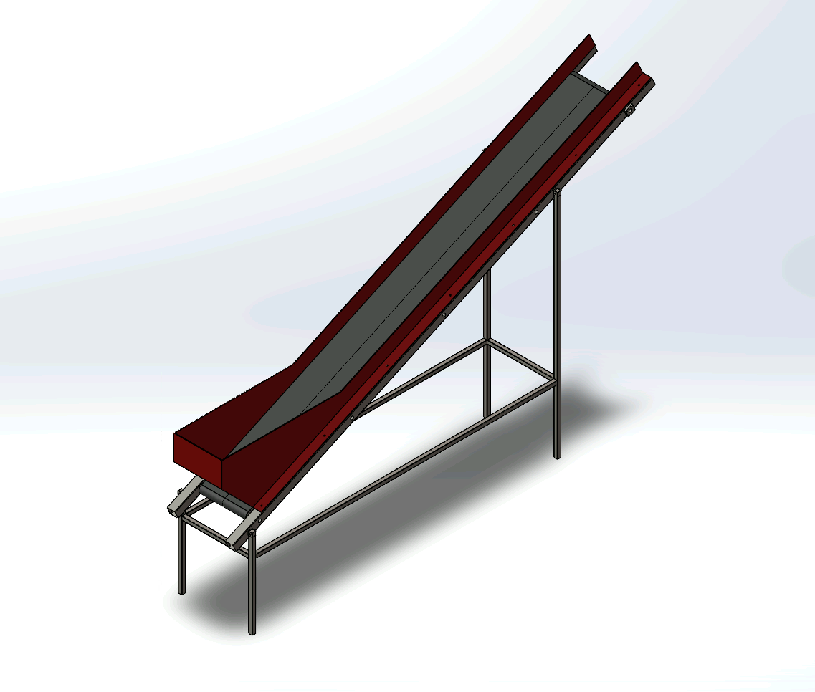
Overall Design

- This configuration was selected to ensure stability during loading and effective material flow control during the elevation phase. The spatial requirements for each segment, including mounting points and support structure, were defined to maintain stability and durability.
- Material Selection and Load Analysis: Lightweight and durable materials were chosen to handle the gravel load, particularly in the inclined section. Structural materials for the frame and legs were selected based on load simulations, ensuring that the conveyor can handle the gravel’s mass and the required power without excessive wear or deformation. CAD simulations were used to test load distribution across both the horizontal and inclined segments.
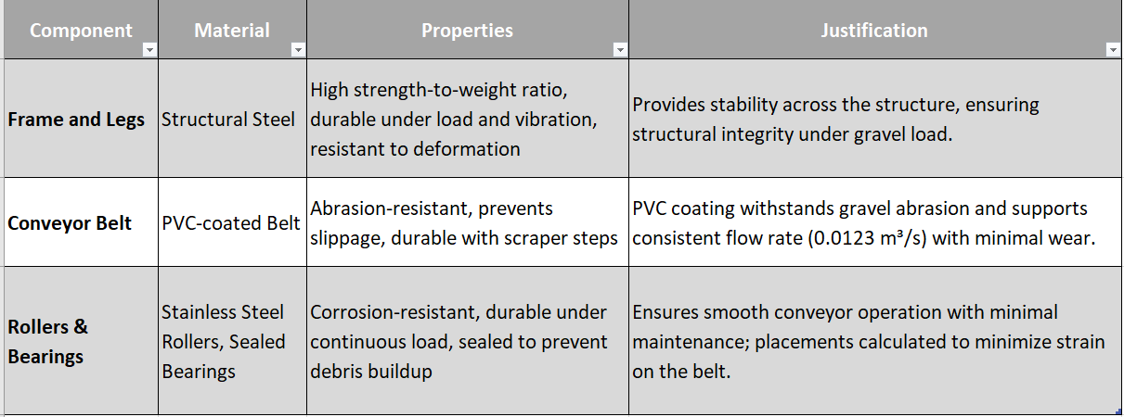

- Component Simulations: Initial simulations focused on refining belt speed, load capacity, and power requirements to meet the 12-minute target for loading the truck bed. With scraper steps added to prevent material slipping, simulations confirmed that the design would achieve the required flow rate and loading efficiency. (Detailed calculations are provided in the following section.)
Outcomes: The updated conveyor design meets load-time and stability requirements, achieving an efficient balance of power and stability. This configuration addresses operational needs while minimizing risks associated with load consistency and spillage.
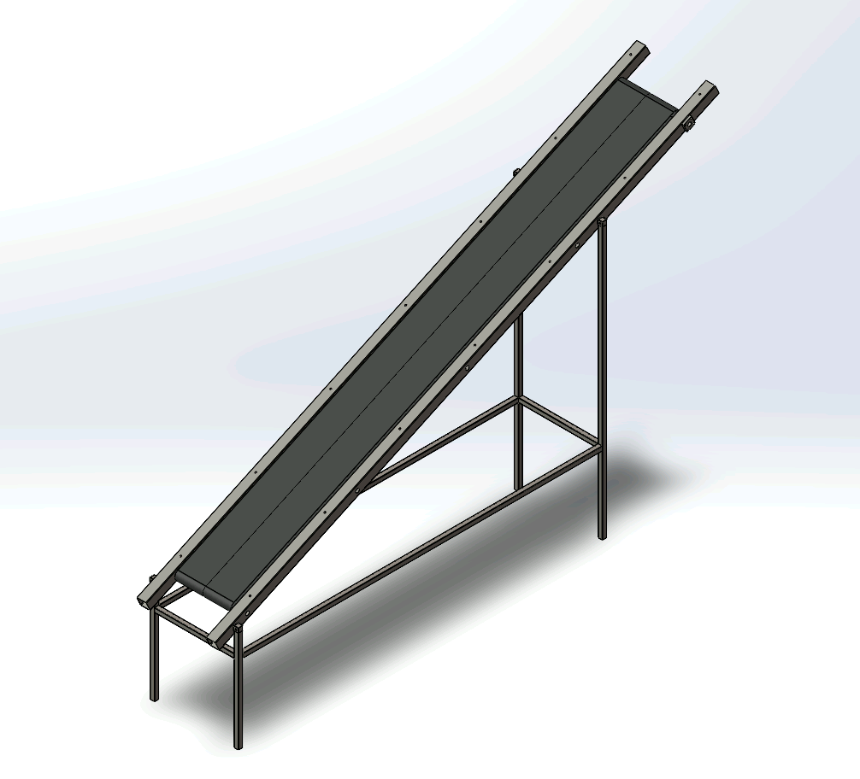
Figure 1: Frame and leg
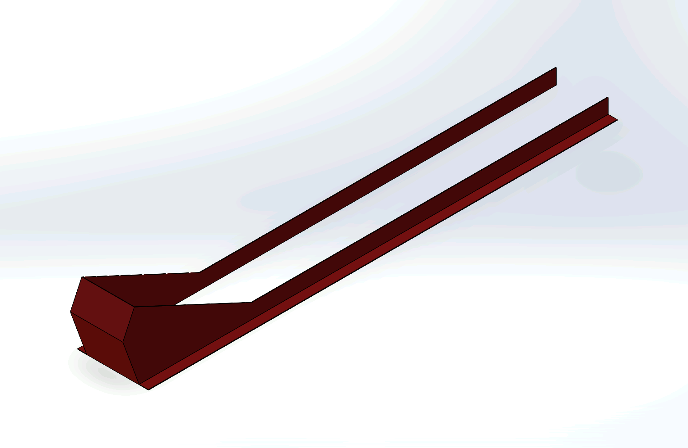

Figure 2: Gravel Guard

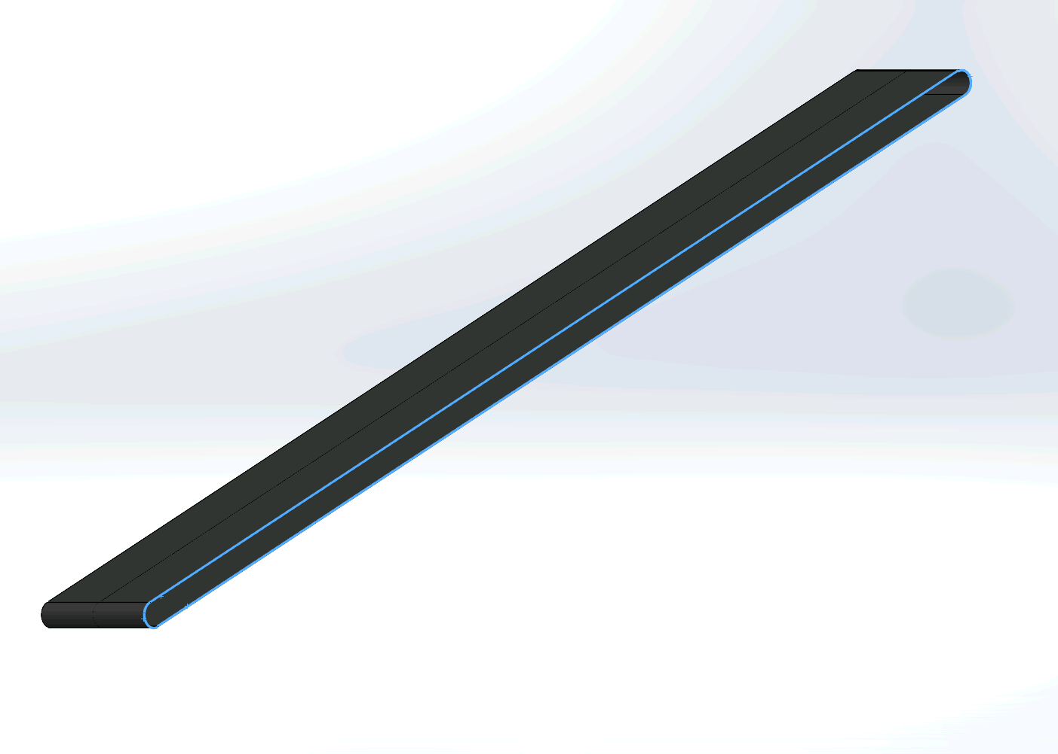
Figure 3: Belt
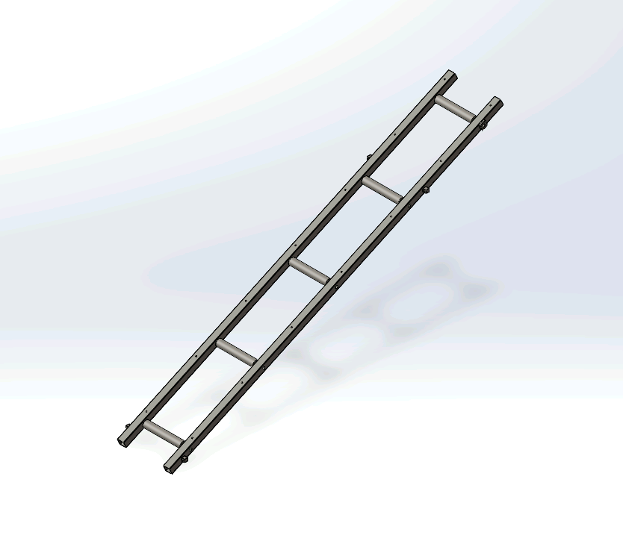
Figure 4: Conveyor Rollers

III. Analysis and Findings

Assumptions
To guide the design of the gravel conveyor system, several foundational assumptions were made based on standard operational conditions and industry norms. These assumptions ensure accuracy in calculations and suitability of material choices for an efficient and durable design:
- Gravel Density: Assumed at 1,500 kg/m³, a standard density for construction gravel. This value aids in determining conveyor strength, motor power, and load-bearing requirements.
- Operational Environment: Assumed standard industrial conditions with temperatures from -10°C to 40°C and minimal chemical exposure. This supports the choice of PVC-coated belts and structural steel, which are effective under moderate temperatures and provide abrasion resistance.
- Truck Bed Height and Loading Time: The conveyor must reach a height of 2.44 meters and load within 12 minutes. These parameters shape the required conveyor length, incline angle, and flow rate for practical loading efficiency.
- Flow Rate Consistency: A flow rate of 0.0123 m³/s is targeted to maintain consistent gravel loading, guiding belt speed and power requirements to avoid overloading or underloading.
- Material Properties: Structural steel, PVC-coated belt, and stainless steel rollers with sealed bearings were selected for their durability under gravel abrasion and minimal maintenance needs, balancing strength and cost-effectiveness.
- Incline Angle: The conveyor is designed to operate at a 25° incline, minimizing backsliding of gravel while keeping motor power requirements manageable.
- Efficiency and Safety Margins: A mechanical efficiency of 80% and a safety factor of 1.5 account for real-world frictional losses and operational variations, ensuring reliability.

Initial Fully Defined Conditions and Equations
The gravel conveyor design incorporates a horizontal segment followed by an inclined segment with scraper steps. This setup affects calculations for length, force, and power requirements, as detailed below

1. Key Parameters and Initial Conditions
- Truck Bed Height: The conveyor must reach the truck bed’s top edge, which is 8.0 ft (2.44 m) above the ground.
- Truck Bed Dimensions: Width = 6.5 ft, Length = 12.0 ft, Depth = 4.0 ft (1.98 m × 3.66 m × 1.22 m).
- Filling Time: Target 12 minutes or less to load the truck bed with gravel.
- Material Density of Gravel: Assumed to be approximately 1,500 kg/m³.
- Incline Angles (θ₁): 25°.

2. Detailed Governing Equations and Adjustments
The conveyor is designed as a single-inclined segment at a 25° angle, requiring calculations for both force and power adjustments specific to this incline. All governing equations focus on the incline’s impact on load stability, force requirements, and power consumption, ensuring the conveyor effectively elevates gravel to the required height.

a. Flow Rate Requirement (Q)
To fill the truck bed within 12 minutes, the required flow rate Q is calculated as follows:
$Truck Bed Volume=Width⋅Length⋅Depth=1.98⋅3.66⋅1.22=$ 8.84 m³
$Q=\frac{Truck Bed Volume}{Filling Time}=\frac{8.84}{(12⋅60)}=$ 0.0123 m³/s

b. Conveyor Length for Each Segment
The conveyor is designed as a single inclined segment at a 25° angle, with a maximum height of 2.9 m to allow for loading into trucks and trailers. To achieve this elevation, the conveyor belt starts 1 m off the ground at its lowest point. The length of the inclined segment $L$ is calculated based on the 2 m vertical rise from the initial height of 1 m.
- Inclined segment angle: 25°
- Inclined vertical height: 2 m
$L_{}=\frac{2}{sin(25°)} ≈$ 4.73 m
Thus, the total conveyor length L, considering both segments, is:
$L=$ 4.73 m

c. Belt Speed
With scraper steps, the conveyor can manage steeper angles, maintaining gravel stability on the belt. Assuming a belt width of 0.51 m and gravel depth of 0.2 m, the cross-sectional area A is:
$A=0.5⋅0.2=$ 0.10 m²
The belt speed v needed to maintain the required flow rate Q is then:
$v_{belt}=\frac{Q}{A}=\frac{0.0123}{0.1} ≈$ 0.123 m/s
To ensure that the gravel conveyor system meets the operational requirements within the 12-minute target and addresses practical considerations, we have decided to increase the belt speed to 2 m/s. While theoretically sufficient, the original calculation of 0.123 m/s may underestimate real-world conditions. Practical conveyor operation often encounters uneven gravel distribution, additional frictional forces, and mechanical inefficiencies due to scraper steps and other components that help prevent material backsliding. Industry standards for similar applications typically use belt speeds of 1–3 m/s to maintain consistent flow and reliability.

d. Force Requirement for Each Segment
Since the inclined segment of the conveyor must support and move a continuous load of gravel along its entire length, the total force required needs to consider both the flow rate and the static weight of the gravel distributed along the belt.
- Mass flow rate $m=Q⋅ρ=0.0123⋅1500=$ 18.45 kg/s
- Force for the inclined segment: $F=m⋅g⋅sin(θ_{1})$
$F = 18.45⋅9.81⋅sin(25°) ≈$76.5 N
To account for the entire length of the belt full of gravel, we need to consider the force due to the weight of the gravel distributed across the inclined segment.
- Step 1: Calculate the Volume of Gravel on the Belt
$A = Belt Width ⋅Gravel Depth = 0.6⋅0.2 =$ 0.12 m²
$V_{belt}= A⋅L_{}=0.12⋅4.73 ≈$ 0.5676 m³
- Step 2: Calculate the Mass of Gravel on the Belt
$m_{belt}=V_{belt}⋅ρ=0.5676⋅1500 ≈$ 851.4 kg
- Step 3: Calculate the Total Force
$F_{total}=m_{belt}⋅g⋅sin(θ_{1})=851.4⋅9.81⋅sin(25°) ≈$ 3529.8 N

Combined Force Requirement: The total force needed includes the original flow force plus the force required to move the gravel along the entire belt:
$F_{combined}=F_{flow}+F_{total} ≈ 76.5+3529.8 ≈$ 3606.3 N

e. Total Power Requirement
The power needed to operate the conveyor:
$P_{1}=F⋅v=3606.3⋅2 ≈$ 7212.6 W
With a mechanical efficiency of 80%, the actual power required is:
$P_{actual}=\frac{7212.6}{0.8} ≈$ 9015.8 W

With a safety factor of 1.5, the design power required is:
$P_{design}=9015.8⋅1.5 ≈$ 13523.7 W

Summary of Initial Conditions and Equations
With the conveyor design having a horizontal segment followed by an inclined segment, the operational parameters are as follows:
- Total Conveyor Length: Approximately 4.73 m
- Flow Rate Q: 0.0123 m³/s.
- Belt Speed v: 2 m/s.
- Force: 3606.3 N.
- Total Power Requirement: Approximately 13523.7 W, accounting for efficiency.
- Belt Width: 0.5 m

3. Motor Selection for Conveyor System

a. Power Requirement
The required power for the inclined conveyor segment was calculated as:
$P_{design}=$ 13.5 kW

b. Motor Speed (RPM) Calculation
The conveyor’s belt speed, calculated to maintain the required gravel flow rate, is:
$v =$ 2 m/s

Assuming a pulley diameter D = 0.09 m, the motor’s rotational speed (in RPM) can be calculated using:
$RPM = \frac{(v⋅60)}{πD}$
Substitute the values:
$RPM = \frac{(2⋅60)}{(π⋅0.09)}=$ 424.4 RPM

c. Torque Requirement
Next, we calculate the torque T required for the motor using:
$T = \frac{P_{design}}{ω}$
where ω is the angular velocity in radians per second, calculated as:

$ω=\frac{(2π⋅RPM)}{60}$
Substitute the RPM value:
$ω=\frac{2π(424)}{60} ≈$ 44.44 rad/s
Then, the torque T becomes:
$T = \frac{13523.7}{44.44} ≈$ 304.3 Nm

Thus, the motor should provide approximately 304 Nm of torque.
Summary of Motor Requirements
Based on the calculations, the motor specifications for the conveyor system should be:
- Power: Minimum 13.5 kW
- Speed: Around 424 RPM
- Torque: At least 304 Nm

Recommended Motor Types
Considering these requirements, we identified the following motor types available in the SolidWorks library that are suitable for gravel conveyor applications:
- AC Induction Motor with Gear Reduction (16.5 kW): Provides robust, low-maintenance operation, ideal for continuous heavy loads. The gear reduction ensures the motor operates efficiently at the required RPM.
- Permanent Magnet Synchronous Motor (17 kW): Provides high efficiency and precise speed control, ideal for applications requiring consistent performance.
- Servo Motor with High Torque Output (20 kW): Offers flexibility in speed control and high starting torque, ideal for handling variable loads.

Key Takeaways and Implications for Future Work:
- Efficiency and Flow Control: The segmented design with a horizontal loading section followed by an inclined elevation section has shown promising efficiency in maintaining the required flow rate. To further optimize, we will continue to refine the conveyor belt speed and adjust the scraper steps for consistent material flow control.
- Stability and Safety: The conveyor’s stability is achieved with reinforced structural steel supports, particularly at the transition to the inclined segment. For operator safety, additional features such as an automatic shutdown mechanism are planned, allowing for emergency stops in case of overload or malfunction.
- Cost and Resource Allocation: Although material and component costs are within the approved budget, assembly and testing are anticipated to require ongoing resource monitoring. By focusing on durable materials and a modular design, we expect to reduce maintenance costs over the conveyor’s operational lifespan.

IV. Upcoming Tasks and Goals

Critical Design Phase (November 16 - December 5)
The Critical Design (CD) phase will focus on finalizing and verifying the system’s design and functionality. Key tasks include:
- CAD Model Refinement: Complete component and assembly details in CAD to ensure system integrity, particularly in support structures and belt tension mechanisms.
- Component-Level Analysis and Virtual Stress Testing: Perform detailed simulations on individual components, such as belt tension mechanisms, support structures, and scraper steps. These targeted analyses will assess durability, stress distribution, and potential points of failure under various load scenarios. This focused testing ensures each component can withstand operational demands, supporting overall system reliability without the need for a physical prototype.
- Simulation-Based Performance Assessment: Use detailed digital simulations to assess real-world performance, safety, and durability of the conveyor system. Conduct virtual testing under various load conditions to identify potential issues with material handling and speed control. This approach will allow for iterative design improvements without the need for a physical prototype, ensuring that the conveyor meets all performance and safety standards before final implementation
Goals:
- Optimize Performance: Fine-tune belt actuation speeds and ensure scraper steps maintain gravel stability for effective loading.
- Integrate Safety Features: Implement automatic shutdown protocols and test stress resistance for operational stability.
- Enhance Component Reliability: Use virtual stress tests to confirm durability under anticipated load conditions, identifying any potential weak points in critical components.
- Budget Compliance: Continue to monitor resource allocation for simulation software and analysis tools to stay aligned with the project budget.
Assigned Responsibilities:
- CAD and Model Finalization: YUVRAJ GHUMAN, AMRAZ MANGAT
- Computations and Stress Analysis: THANH NAM TRAN, KEITARO BONAFE
- Performance Evaluation and Component Simulations: KEENAN D'SENA

V. Conclusion
This report outlines significant progress in the development of a gravel conveyor system designed to elevate gravel to a truck bed with high efficiency, stability, and durability. Key achievements include meeting the required flow rate of 0.0123 m³/s within the target loading time of 12 minutes and ensuring structural integrity across both horizontal and inclined segments. The selected materials, such as structural steel for the frame and PVC-coated belt, provide optimal strength and abrasion resistance, ensuring that the system withstands the demands of gravel conveyance with minimal wear.
However, several challenges remain to be addressed in the upcoming design phase. These include refining belt speed for consistent material flow, optimizing the scraper steps to prevent backsliding on the incline, and integrating safety mechanisms like an automatic shutdown for overload protection. The Critical Design (CD) phase will focus on enhancing component reliability through virtual stress testing and simulation-based performance assessments to ensure that each component withstands operational loads without failure.
Moving forward, our primary goals are to fine-tune the system for optimal performance, integrate safety features, and verify durability through targeted stress analyses. These steps will further enhance the conveyor’s efficiency, safety, and cost-effectiveness, positioning us to meet or exceed all project objectives by the final deadline.
By concentrating on these improvements, we are confident that the gravel conveyor system will meet industry standards for reliability and operational efficiency, providing a robust solution for gravel handling needs.

https://www.engineeringtoolbox.com/conveyor-belt-speed-d_506.html
https://www.sungda.com/index.php/how-to-choose-the-right-conveyor-belt-speed/

